Katerpillarz
Game Design Document
By: Karen Kenward
CIS 297 – Intro to C #
Due: 4/8/2010

Executive Summary

- Abstract
Katerpillarz is an arcade game for Windows and Xbox 360. It is similar to the video game Centipede. In Katerpillarz, the player must defend the crops against invading caterpillars. Being good to the environment by avoiding dangerous insecticides, the player releases caged birds, which are a natural enemy to the caterpillar. When a bird is released from the cage, it will eat a segment of the caterpillar, if it encounters one. The game is won when all the caterpillar segments are eaten before they can reach the cage or the crops below.

- Game Play & Appearance
The game will begin with a splash screen where the player can select to view the Help screen, Credits screen, or Play the game. The scene begins with a bird in a cage above an area of green crops. The player can control the movement of the cage from side to side and, to a small degree, up and down. At the top left of the screen, a 13 segment caterpillar will appear, marching back and forth across the screen. When the caterpillar encounters and obstacle, such as a rock or a mushroom, it will turn around and continue its march a little bit closer to the crops. The screen is scattered with rocks and mushrooms.

The player can release the birds, one at a time, by pressing the fire button. A bird will fly straight up. If it encounters a mushroom, the bird will eat the mushroom and die. If the bird encounters a segment of the caterpillar, it will eat one segment, before continuing off the screen. The object of the game is to clear all the caterpillar segments away before they reach the cage or the crops.

When a caterpillar segment gets killed, it may cause the caterpillar to split in two. The segment that was behind becomes a new head and moves away in the opposite direction and increases speed. Each caterpillar’s speed is determined by the number of segments it has following it. This will make it more challenging for the player to aim the birds at multiple segments.

Occasionally, a friend or foe may appear from above. Random appearances of wasps or spiders may help or hinder the birds. Wasps will kill the caterpillar segments and birds, alike. Spiders will ignore the caterpillar, but if a bird eats the spider, the player will gain an extra life.

The player is given 3 lives to eliminate the caterpillar before it invades the crops. Various points will be earned as the birds eat caterpillar segments, mushrooms, and spiders.

- Development Specification
This project will need to be broken down into smaller tasks
  - Game Design and Planning
    - Decide on the type of game to create
    - Design mockups of screens
    - Plan look and feel of the game
    - Layout the flow of the game
    - Creating design Document
  - Creation of Assets
    - Sprites
      - Cage
      - Bird
      - Caterpillar Head
      - Caterpillar Segment
      - Wasp
      - Spider
    - Backgrounds
      - Crops
      - Background
      - Mushrooms
      - Rocks
    - Music
      - Ambiance
      - Winning the game
      - Losing the game
    - Sound Effects
      - Bird leaving cage
      - Bird eating Caterpillar, Mushroom
      - Wasp buzzing
  - Defining Interactions
    - Bird encounters Caterpillar
    - Bird encounters Mushroom
    - Bird encounters Spider
    - Bird encounters Wasp
    - Caterpillar encounters obstacle
    - Caterpillar encounters enemy
    - Caterpillar encounters Cage, Crops
    - Wasp encounters enemy
    - Spider encounters Bird
    - Cage encounters enemy
  - Coding
    - Implement the interactions
    - Defining game states, counters
    - Manage user input
  - Testing
    - Test all interactions
    - Test game flow
    - Make adjustments to code
    - Port to XBox 360
    - Test on Xbox 360

Product Specification

- Production Team
Project Manager – Karen Kenward, former Visual Basic programmer trying to gain some updated skills to reenter the working world. Coordinates resources, project planning, and manages time constraints. Directs team members.
Script Writer – Karen Kenward. Responsible for planning storyline.
Level Designer – Karen Kenward. Uses art materials to build each level of game play using Torque X.
Programmer – Karen Kenward. In charge of writing all game code.
Artist – Karen Kenward and Quinn Kenward, Karen’s 12 year old son and budding entrepreneur. Created sprites, backgrounds, splash screen and various other artwork.
Musician – Quinn Kenward. Compiled music and sound effects.
Testers – Karen Kenward, Quinn Kenward, and Nathan Kenward, Karen’s 8 year old son and future engineer. Test the play of the game to pinpoint any problem areas.

- Target Audience
The target audience for Katerpillarz is primarily young children and infrequent gamers. The game is ideal for these two groups because it is easy to learn and quick to play in short periods of time.

- Production Tools
Visual Studio 2008 – Professional Edition
Microsoft .Net Framework
XNA Game Studio 3.1
Torque X Builder 2D
Paint.NET
XACT 3

Game Specification

- Playing the Game
Controls
The player will use an Xbox 360 Gamepad to play Katerpillarz. The left thumbstick will control the movement of the bird cage within the confined area above the crops. Pressing the fire button or “A” will release a bird to fly up the playing field.

Strategy
The player must aim the bird to reach the caterpillar. The player may also want to aim the bird at mushrooms to eliminate obstacles. When a caterpillar hits an obstacle, like a rock or a mushroom, it turns and moves a bit closer to the bottom. Removing obstacles will increase the length of time it takes the caterpillar to move down the playing field. The player must avoid the wasps. Wasps will kill the bird and the cage, alike. Catching the spider with the bird will help the player with both points and extra lives.

Points
Each time a bird eats a mushroom, though it kills the bird, the player will have 300 points added to his score. When a bird eats a segment of the caterpillar, the player earns 500 points. The bird eating the head will gain the player 600 points. If the bird is lucky enough to catch a spider, the player will earn an extra life, as well as 1000 points.

Movement
The cage will move side to side and slightly up or down in the area above the crops. Birds will fly straight up the screen from the point where they were released. Wasps and Spiders will move straight down from the top of the screen, at random times and locations. The caterpillar will travel side to side, turning and descending slightly when encountering obstacles. If a caterpillar segment dies, the caterpillar gets divided. The two parts continue in opposite directions and at faster rates.

Sounds
During game, some lively music will play. Releasing the birds will cause a sound like a caw. Likewise, when the bird eats a mushroom or a caterpillar, another bird noise will sound. As soon as a wasp appears, a buzzing sound will be heard. The spider makes no noise at all. If the caterpillar reaches the cage or the crops, some fail music will play. Defeating the caterpillar will trigger the success music.

- Interface Mockup
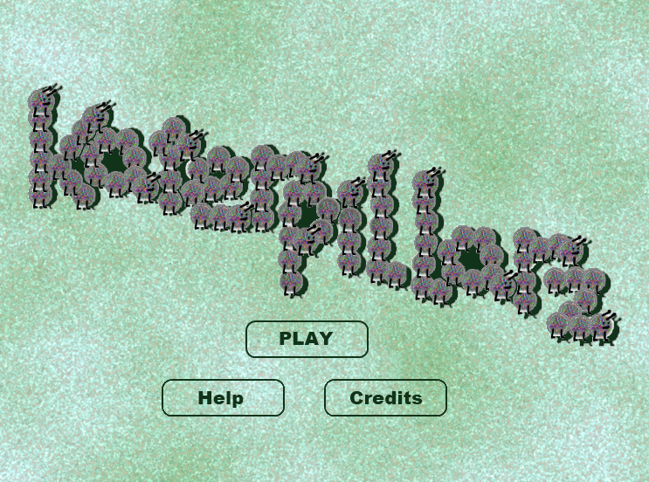

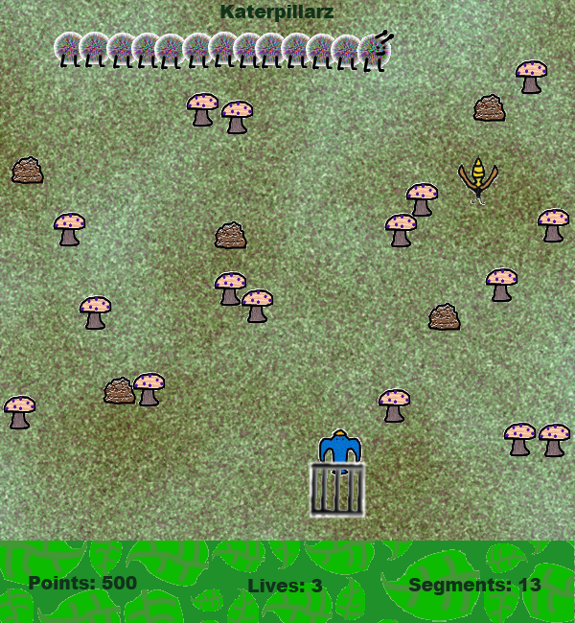

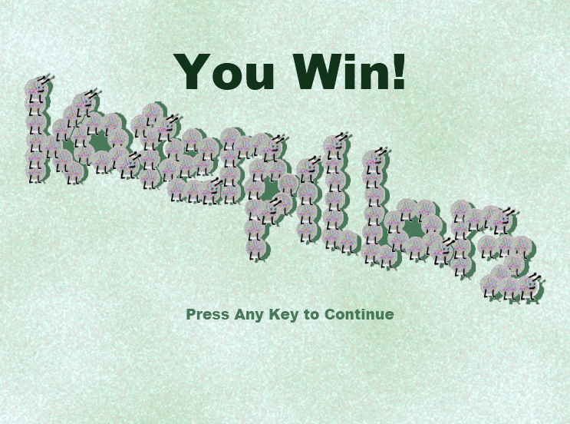

- Story Line
In Katerpillarz, the player must defend the crops against invading caterpillars. Being good to the environment by avoiding dangerous insecticides, the player releases caged birds, which are a natural enemy to the caterpillar. When a bird is released from the cage, it will eat a segment of the caterpillar, if it encounters one. The game is won when all the caterpillar segments are eaten before they can reach the cage or the crops below.

Occasionally, friends or foes appear, sometimes helping the player and sometimes hurting the player. Wasps are an enemy to both the caterpillar and the birds. A wasp will sting and kill a caterpillar segment or the bird, if it encounters one in its flight. A wasp will sting once, then die. Spiders will appear once in a while. A spider will ignore the caterpillar, and vise versa. If a bird encounters a spider, it will eat the spider. This gives the player points and an extra life.

- Characters

  Bird  - Release from Cage  - Eats Head, Segment  - Eats Spider  - Killed by Wasp | 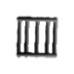  Cage  - Killed by Head, Segment  - Killed by Wasp |   Spider  - Eaten by Bird  - Gives Player extra Lives  - Gives Player 1000 points
  Head  - Eaten by Bird  - Killed by Wasp  - Kills Cage  - Gives Player 600 points |   Segment  - Eaten by Bird  - Killed by Wasp  - Kills Cage  - Becomes Head if parent Segment dies  - Gives Player 500 points | 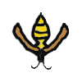  Wasp  - Kills Bird  - Kills Head, Segment  - Kills Cage

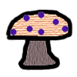  Mushroom  - Obstacle for Caterpillar  - Eaten by Bird  - Gives Player 300 points |   Rock  - Obstacle for Caterpillar  - Ignored by everything else |   Crops  - Protected by Player  - Goal of Caterpillar

- Flowchart
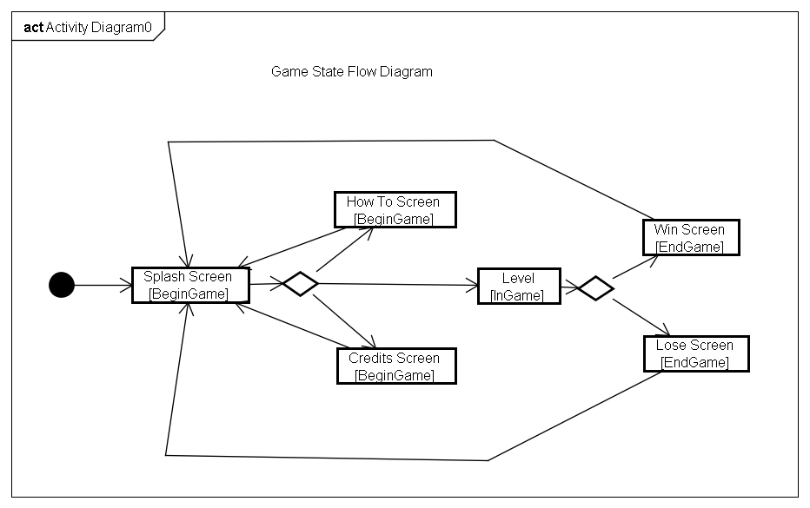

- Level Outlines
Each level has an area littered with rocks and mushrooms. This is the playing field. Below, is an area of crops. Between the playing field and crops is a cage of birds, which is controlled by the player. The player can move in an area confined between the playing field and layer of crops. A bird is released when the player presses the fire button. When a bird is released, it flies straight up the playing field, eating a caterpillar segment or mushroom it may encounter.

A 13 segment caterpillar, consisting of a head and 12 segments, appears in the upper left part of the screen. The caterpillar marches from side to side. As it encounters obstacles or the edge of the playing field, it turns and descends to a lower row of the screen. When a segment or head gets killed, the remaining caterpillar may split into two caterpillars. The child segment becomes a head and travels in the opposite direction. The speed of a caterpillar will depend on the number of segments following it. The fewer segments in a caterpillar, the faster it can travel.

Random appearances of wasps and spiders from the top of the screen will add to the layout. Wasps will kill segments or heads of caterpillars. They will also kill birds and cage, causing the player to lose a life. Spiders will travel across the screen. If a bird eats a spider, the player will earn an extra life.

If the caterpillar gets to the cage or crops, the player loses a life and the level begins again. When the entire caterpillar is gone, the player wins the level and an extra life. Subsequent levels will have higher number of caterpillar segments, travelling at faster speeds. They may have different arrangements of obstacles. The appearance of wasps and spiders will increase, as well. The game will continue as long as there are additional levels to conquer.

